**Ideation Phase - Empathize &Discover**

|  |  |
| --- | --- |
| Date | June 2025 |
| Team ID | LTVIP2025TMID58285 |
| Project Name | Service Desk for Customer Complaint Resolution |
| Maximum Marks | 4 Marks |

**Empathy Map Canvas**

**User Persona: *John – A frustrated citizen facing service issues***

|  |  |
| --- | --- |
| **Thinks** | **Feels** |
| "Will anyone even look at my complaint?" | Frustrated due to lack of proper response |
| "I want to help improve the system" | Anxious about how long the process will take |
| "Why isn't there an easier way to report issues?" | Feels neglected and not valued as a citizen |

|  |  |
| --- | --- |
| **Says** | **Does** |
| "I submitted a complaint but never got a reply" | Tries to contact officials but receives no updates |
| "There should be a transparent way to track complaints" | Takes screenshots, writes long explanations |
| "Nobody is listening to our problems" | Abandons filing complaints out of disappointment |

**Pain Points:**

* Difficulty in knowing where to file complaints
* Lack of updates and transparency
* Long delays in resolution
* Poor user experience in existing systems

**Needs & Goals:**

* A user-friendly platform for filing complaints
* Real-time tracking of complaint status
* Interaction with the responsible department/agent
* Trustworthy and responsive system

**Example:**

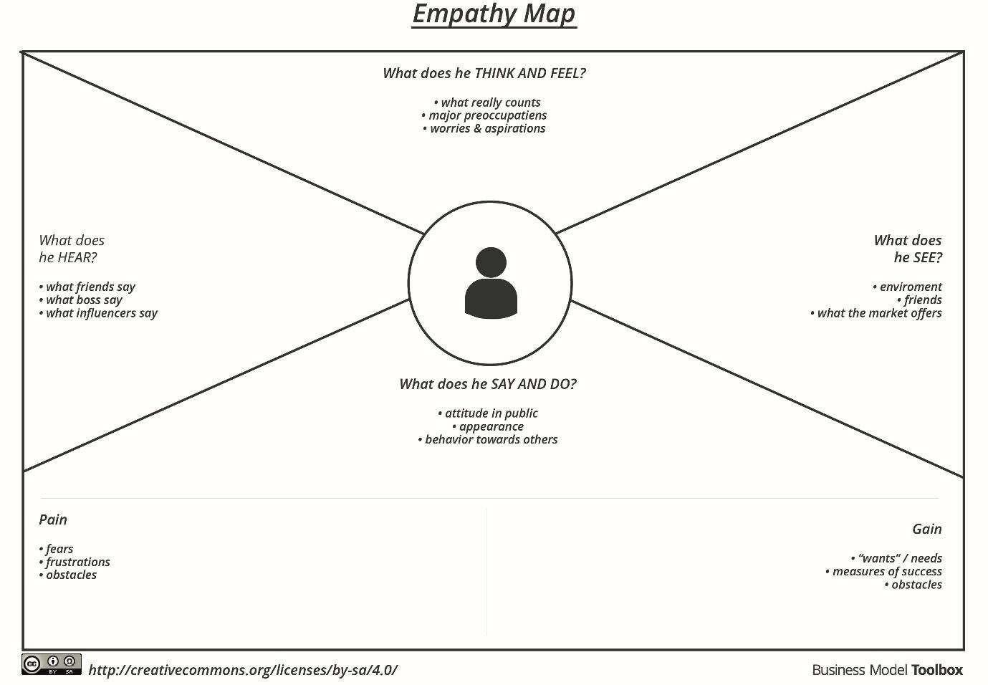

Reference: https://[www.mural.co/templates/empathy-map-canvas](http://www.mural.co/templates/empathy-map-canvas)